1. **INTRODUCTION**

* 1. **Overview**

House price prediction in a metropolitan city in India is a valuable solution for potential home buyers, real estate agents, and investors. By leveraging historical sales data, property details, and location-specific information, a predictive model can accurately estimate house prices. The model's scalability, real-time updates, user-friendly interface, and transparency ensure it meets the needs of stakeholders. Integration capability, data privacy, and cost effectiveness are also important considerations. By addressing these requirements, the prediction model provides reliable insights, empowering stakeholders to make informed decisions in the fast-paced real estate market.

* 1. **Purpose**

By this project not only presents the data in a visually appealing manner but also provides an interactive experience for readers to explore the intricacies of House price prediction in a metropolitan city in India. To Extract the Insights from the data and put the data in the form of visualizations, Dashboards and Story we employed Tableau tool.

1. **PROBLEM DEFINITION & DESIGN THINKING**

**2.1 Empathy Map**

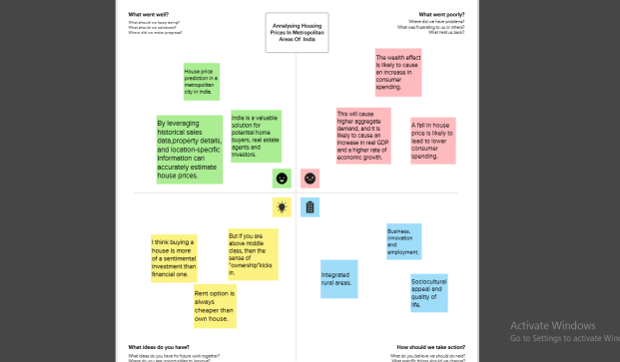

**2.2 Ideation & Brainstorming Map**

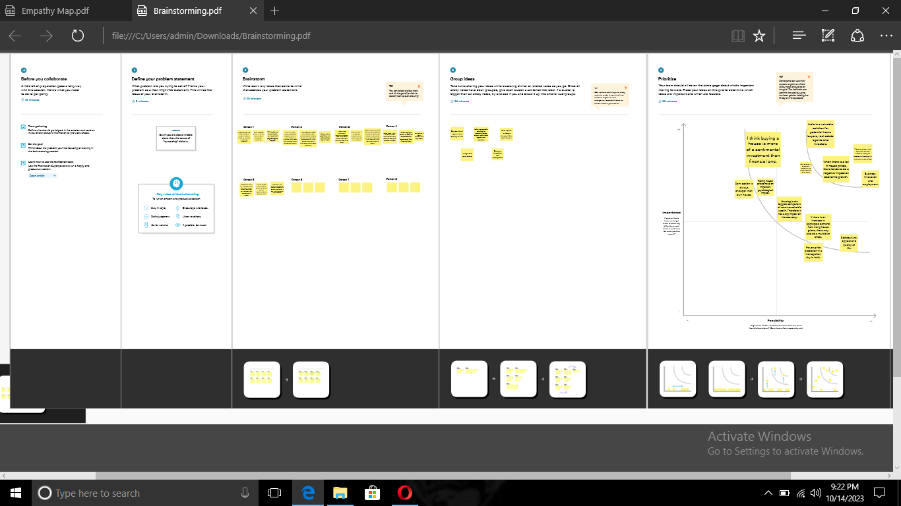

1. **RESULT**

**Output of the Project**

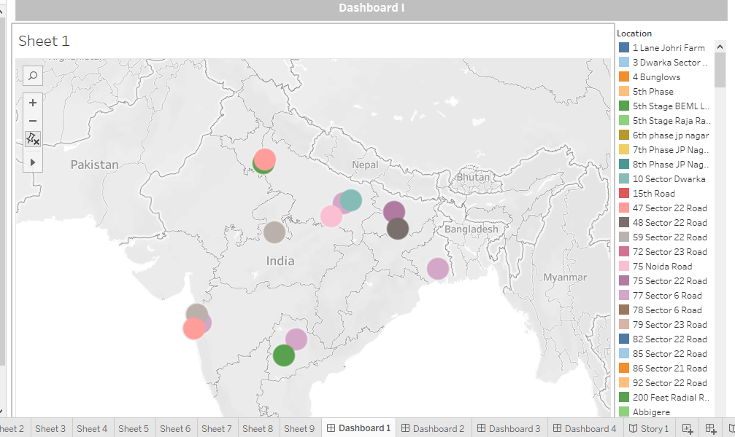

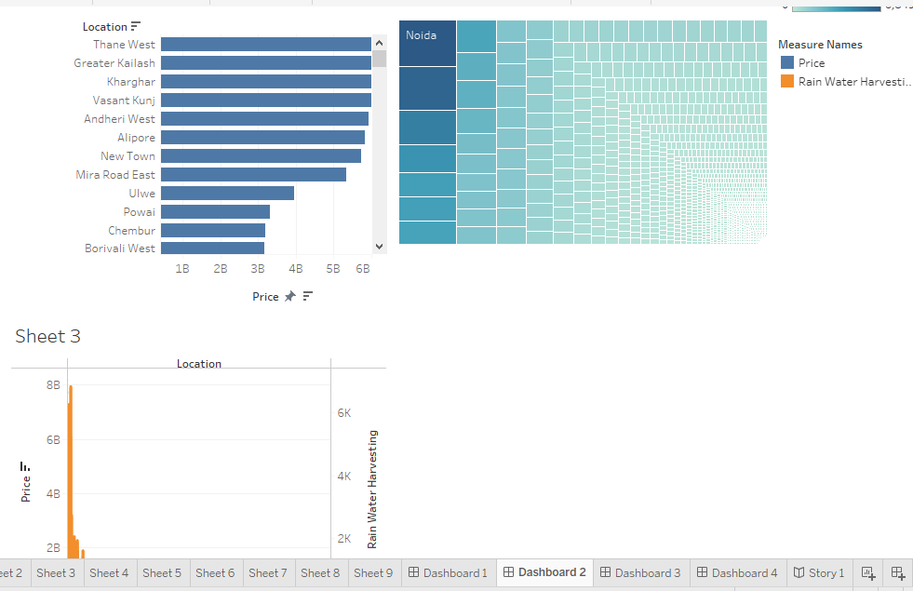  
 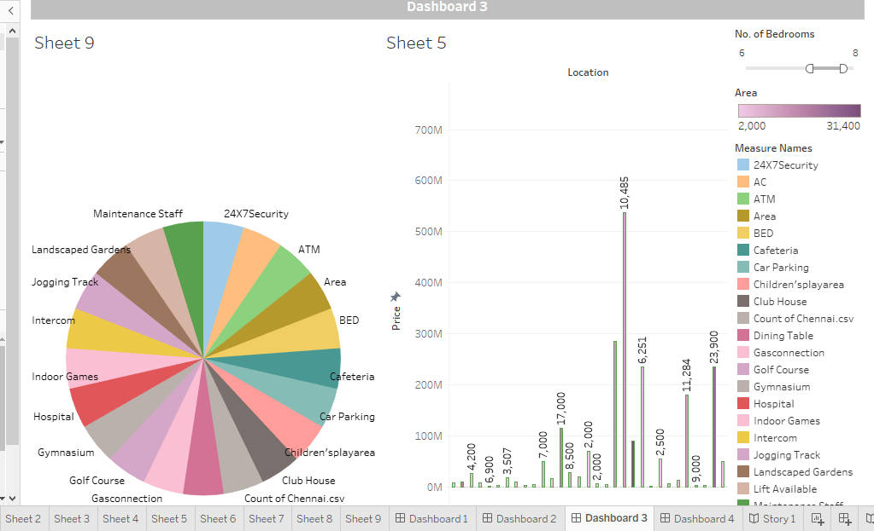

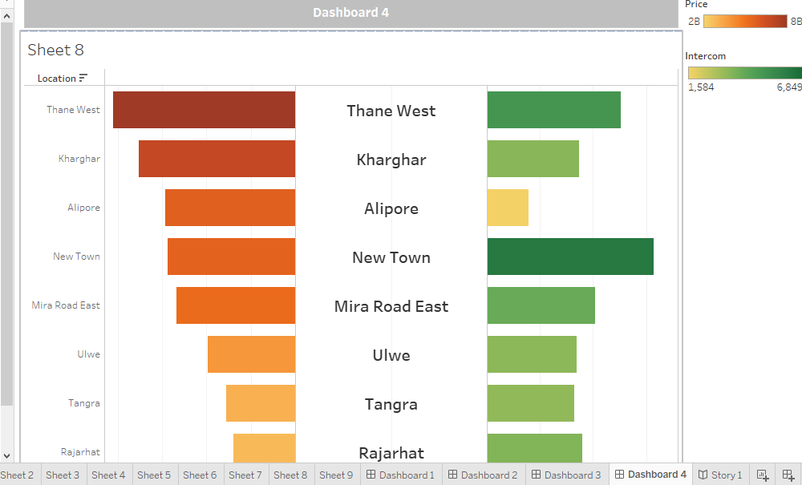

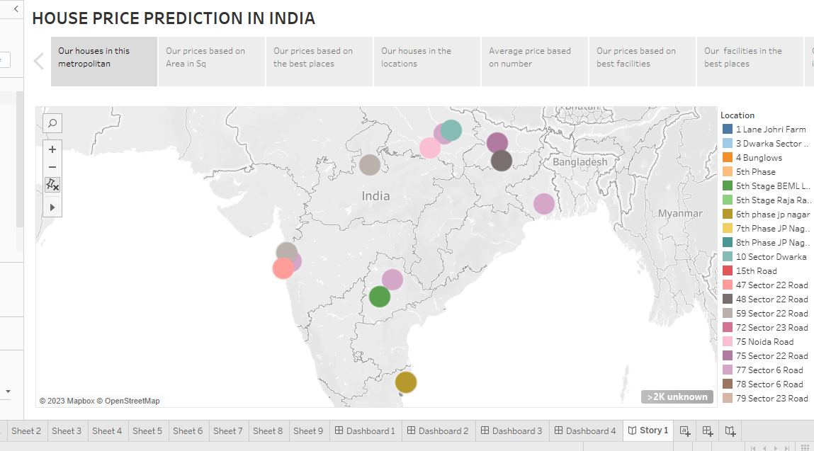

1. **ADVANTAGES & DISADVANTAGES**

**Advantages:**

* **This Project examines the historical context of House price prediction in a metropolitan city in India.**
* **House price prediction can help the developer determine the selling price of a house and can help the customer to arrange the right time to purchase a house.**
* **The survey explores the diversity of crops cultivated across different regions, along with trends in production and the impact of climate variability.**
* **There are three factors that influence the price of a house which include physical conditions,concept and location.**

**Disadvantages:**

* **On the supply side, scarcity of developed and encumbrance-free urban land, increased cost of construction, growing informal housing options, absence of viable rental market and master-plan restraints have lowered the potential growth of formal affordable housing market.**

1. **APPLICATIONS**

**Some common types of visualizations that can be used to analyses the performance and efficiency of banks include bar charts, line charts, heat maps, scatter plots, pie charts, Maps etc.**

**5.1 Houses in the metropolitan**

**5.2 Housing prices based on Area in Sq**

**5.3 Housing prices based on the best places**

**5.4 Houses in the location**

**5.5 Average price based on number**

**5.6 Prices based on best facilities**

**5.7 Facilities in the best places**

**5.8 Housing prices based on intercorn**

**5.9 Our services in some places**

1. **CONCLUSION**

**First, we have to understand the given problem. Then, specify the business problem and collect the process of gathering and measuring information on variables of interest, evaluate outcomes and generate insights from the data. Then, download the data and understand the data, connect dataset with Tableau. After, connect dataset with Tableau, preparing the data for visualization involves cleaning the data to remove irrelevant or missing data. This process helps to make the data easily understandable and ready for creating visualizations to gain insights into the performance and efficiency. Then, the number of unique visualizations that can be created with a given dataset. Some common types of visualizations that can be used to analyses the performance and efficiency of banks include bar charts, line charts, pie charts etc. Once created views on different sheets in Tableau, then pull them into a dashboard. The number of scenes in a story for a data visualization analysis of the performance of banks will depend on the analysis and the specific insights that are trying to be conveyed. Then, publish dashboard, story, and reports to tableau public. Once upload was complete, a browser window will automatically open, displaying your published workbook on Tableau Public.**

1. **FUTURE SCOPE**

**My Future scope is nothing but, more features to add on tableau like download option for download the project. Then, it takes more times to open. So, make it is easy to operate.**